

# Research Brief 13/151

### 04 July 2013

# INCENTIVES INCREASE FORMAL FEMALE EMPLOYMENT

Gokce Uysal*

### [1]Executive Summary

This research brief focuses on the effects of the social security premium incentives granted for women and youth employment and analyzes the effects of these incentives on formal employment among women in the 30-44 age group. This practice started in 2008 and has continued since under various different regulations. The analysis is carried out using data provided by TurkStat (Turkish Statistical Institute). The data indicates that the incentives had a positive effect particularly on the employment of married women who have low levels of education. Results imply that it is mostly the large companies operating in the industrial sector that benefit from the incentives. However, other incentives such as regional incentives, tax incentives to all new job creation, etc, that were enacted meanwhile, undermine the positive effects of this policy. This finding implies that policy-makers should take into account all possible interactions between incentives when designing laws and regulations.

## Introduction

A growing population, thus a rapidly growing workforce, coupled with dissolution in agricultural employment due to the ongoing structural transformation, makes it difficult to combat unemployment in Turkey. In addition to these factors, Turkey ranks among the lowest when it comes to international comparisons based on gender and total workforce statistics due to the low level of women's participation in workforce and employment. Recently, policymakers have been working towards designing various policies to address the structural problems of the labor market in Turkey. One of the most important regulations in this regard is the introduction of tax incentives to employment. The main axis of these incentives is that the employer contributions in social security premiums for formal (registered) employment are paid, fully or partially, by the Unemployment Insurance Fund for certain periods.

In this research brief, the incentives ushered in for women's employment will be summarized, and their relative effects on women's employment will be examined using descriptive statistics. The social security premium incentives provided for formal employment of women, render the employment of women relatively less costly for firms compared to that of men. From this perspective, the incentives entail positive discrimination for formal employment of women. The analysis focuses on the effects on formal employment of women in the 30-44 age group, which is considered to be the most productive age bracket in the labor market.

The data used in the analysis is monthly macro labor market data provided by TurkStat.[2] The analysis points to promising results in terms of formal employment of women. Data show that, thanks to incentives initiated for women's employment in July 2008, formal employment for women in the 30-44 age group increases faster compared to that of men in the same age group. This relative improvement seems to be particularly strong in the employment of married women who are at most high school graduates. Also women working in the industrial sector in relatively large firms as skilled manual labor constitute a major group of beneficiaries.

On the other hand, regional employment incentives that are in effect in 49 provinces limit the effects of the incentives provided for women's employment. This is due to the fact that premium incentives are provided for all new employment regardless of gender in provinces benefiting from regional incentives. In other words, since the cost of employment is reduced for both genders in these 49 provinces, the effects of incentives on women's employment will be stronger in the remaining 32 provinces that do not benefit from regional incentives. However, since monthly labor market data are not provided at the provincial level by TurkStat, the analysis was conducted using national data.

The results indicate visible improvements in the formal employment of women in the 30-44 age group compared to that of men. Hence the incentives seem to work. However, similar employment incentives to all new job creation were introduced in August 2009 in an effort to alleviate the unfavorable effects of the economic crisis on the labor market in Turkey. The incentives to new job creation were gender neutral, and thus almost cancelled out the effect of incentives to women’s employment. The incentives provided to all new job creation expired in June 2011, and then the formal employment of women in the 30-44 age group increased again relative to that of men.

The implementation of regional and new employment incentives concurrent with women's employment incentives has weakened the overall effect of the latter. Clearly, policy-makers should take into consideration the interactions between incentives when designing new ones.

## Incentives for employment of women and youth

First started in July 2008, measures to encourage employment of women and youth have continued to date with various changes along the way. According to latest regulations, these incentives will continue until the end of 2015. Moreover, the Council of Ministers has the power to extend them for another 5-year period. However, both the regional incentives and the measures taken to mitigate the effects of the global crisis negatively affecting the Turkish economy weaken considerably the effects of these incentives for employment of women and youth. Below, the incentives to encourage employment of women and youth will be described, and then other regulations that undermine the relative effects of these incentives will be reviewed.

### Legal regulations encouraging employment of women and youth

Social security premium incentives given for employment in Turkey are usually financed through the Unemployment Insurance Fund; hence, these incentives are regulated by provisional articles added to the Unemployment Insurance Law no.4447. In the Unemployment Insurance Law, Provisional Articles 7 and 10 regulate employment of women and youth, and Provisional Article 9 regulates social security premium incentives for all new employment. The contents and effective dates of these articles are summarized below.

Provisional Article 7, added to the Unemployment Insurance Law no.4447 with Law no.5763 on "Amendment of the Labor Law and Miscellaneous Other Laws", introduced social security premium incentives to encourage employment of women and youth for the first time in Turkey. According to Law no.5763, the State (government) will gradually pay the employer shares of the social security premiums of all newly employed women of all ages and youth in the 18-29 age group under some specific conditions. The related section from the relevant article of aforementioned law is provided below:

*"Of those older than 18 and younger than 29 years of age and of women older than 18 years of age regardless of their age, provided that they are not included among the registered insured personnel of an enterprise in their premium and service documents in the six-month period preceding the effective date of this article, for those who are hired and de facto employed within one year following the effective date of this article as an addition to the average number of insured personnel as declared in the premium and service documents of the workplace in the one-year period preceding the effective date of this article, the following portions from the employer contribution share of the social security premiums calculated on the lower threshold of the base income for premium as specified in Articles 72 and 73 of Law no.506 and also in accordance with Article 78 thereof shall be covered from the Unemployment Insurance Fund:*

*a) 100% for the first year,*

*b) 80% for the second year,*

*c) 60% for the third year,*

*d) 40% for the fourth year,*

*e) 20% for the fifth year.*

*"*

Following Law no.5763 that came into effect in July 2008, the incentives were extended till July 2010 with Article 32 of Law no.5838 on "Law on Amendment of Miscellaneous Laws" adopted in February 2009.

Later on, Provisional Article 10 was added to Law no.4447 with Law no.6111 on "Restructuring of Certain Receivables and Amendment of Social Security and Universal Health Insurance Laws and other Miscellaneous Laws and Decree Laws" (which was an Omnibus Law) adopted in February 2011. In accordance with this new article, the incentives given for youth and women's employment were restructured and extended to remain in effect till the end of 2015.

Provisional Article 10 of Law no.4447 expanded the groups foreseen for support. This regulation provides social security premium incentives for relatively longer periods to companies employing women and youth, while also providing incentives, subject to certain conditions, for employment of men aged 29 years or older. According to the latest version of the Law, men aged 29 or older can benefit from social security premium incentives if they hold a vocational qualification certificate, if they are graduates of an educational institution providing vocational education, or if they are employed while registered as unemployed at the Turkish Employment Organization (İŞKUR). In other words, under this article, when those registered as unemployed at the Turkish Employment Organization are employed, the employer contribution share of their social security premiums will be paid from the Unemployment Insurance Fund.

The related section of this Article is as follows:

*"The support specified in this article shall be implemented for the following:*

*a) Men older than 18 and younger than 29 years of age, and women older than 18 years of age,*

*1) for 48 months for holders of vocational qualification certificates,*

*2) for 36 months for those who complete a secondary or higher education degree program provided by a vocational or technical education institution or complete a workforce training course organized by the Turkish Employment Organization,*

*3) for 24 months for those who do not have the certificates or qualifications specified in sub paragraphs (1) and (2),*

*b) for 24 months for men older than 29 years of age who have the certificates or qualifications specified in sub paragraphs (1) and (2) of paragraph (a),*

*c) for 6 additional months if those meeting the conditions of sub paragraphs (a) and (b) are employed while registered as unemployed at the Turkish Employment Organization,*

*ç) for 12 months for those who, while working within the scope of paragraph (a) of Article 4 of Law no. 5510, obtain a vocational qualification certificate or complete a secondary or higher education degree program after the coming into force of this article,*

*d) for 6 months for those older than 18 years of age who do not meet the requirements of (a), (b) and (ç) of this paragraph and who are employed while registered as unemployed at the Turkish Employment Organization*

*."*

To summarize, social security premium incentives given for employment of women and youth were first introduced in July 2008, and then extended until December 2015. However, with a new arrangement coming into force in February 2011, the scope of these incentives was expanded to include some of the men over 29 years of age.

provides a summary of these legal arrangements.

Table 1 Amendments introduced with Provisional Article 10 added to the Unemployment Insurance Law no. 4447

|  |  |  |  |
| --- | --- | --- | --- |
| **Law** | **Date** | **Arrangement** | **Beneficiaries** |
| Law No. 5763 | July 2008 | Incentives started | Women and youth |
| Law No. 5838 | February 2009 | Extended until July 2010 | Women and youth |
| Law No. 6111 | February 2011 | Extended until December 2015 | Women, youth, men receiving vocational education, and unemployed registered at İŞKUR |

### Legal arrangements that undermine the effects of incentives for women and youth employment

Meanwhile, to overcome some of the detrimental effects of the global economic crisis on the labor market in Turkey, some regulations were passed. These new regulations mitigated the overall effect of the social security premium incentives for women and the youth.

With Law no.5921 on "Amendment of the Unemployment Insurance Law and Social Security and Universal Health Insurance Law", Provisional Article 9 was added to the Unemployment Insurance Law no.4447 in August 2009. This provisional article provides that the employer shares of the social security premiums of each newly employed personnel hired within the last six months will be paid by the State for six months.

"For those who are hired and de facto employed as an addition to the number of insured personnel declared in the premium and service documents of April of 2009, until 31.12.2009, provided that they are not among the insured personnel registered in the premium and service documents submitted to the Social Security Authority for the three-month period before the date of employment, the employer shares of the social security premiums as calculated based on the lower threshold for income that is base for premium determined pursuant to Article 82 and mentioned in Article 81 of Law no.5510 shall be paid from the Unemployment Insurance Fund for six months."

With the Law no.5951 on "Amendment of the Law on Public Receivables Collection Procedures and Miscellaneous Other Laws" dated January 2010, the incentives were extended to include those hired until December 2010, and the Council of Ministers was authorized to further extend them to June 2011. However, there are currently no Council of Ministers decisions for extending the incentives. Hence, the incentives were granted for those hired until December 2010, and the premium payments were finalized in June 2011.[3]

In addition to these regulations, some of the regional incentives also include employment incentives. In accordance with Article 4 of Law no. 5084 on "Encouraging Investment and Employment, and Amendment of Miscellaneous Laws", which came into force in 2004 and remained in force until December 2012, the Treasury paid 100% of the employer shares of social security premiums for workplaces situated in organized industrial zones and 80% of the employer shares for other workplaces in 49 provinces[4]. Since all employment is subsidized by incentives for workplaces employing at least 10 people in these regions, the effect of incentives supporting the employment of women and youth would be marginal.

The incentives introduced with Law no. 5084 expired at the end of December 2012; however, the regions were redefined with the Decision no. 2012/3305 of the Council of Ministers, which re-regulated the employment incentives.

Both the incentives introduced for new employment and the regional incentives almost efface the positive effects of women and youth employment incentives, which aim at increasing employment among these groups by decreasing the cost of employing them.

To summarize, social security premium incentives introduced for employment of women and youth in July 2008 are, in effect, the incentives granted for newly created employment in 32 provinces that were not able to benefit from regional incentives in accordance with Law no.5084 until August 2009 and after June 2011. It should be kept in mind the analysis here is based on monthly labor data at the national level due to the lack of province-based data.

## Methodology and data

The analysis conducted in this research brief uses the difference-in-differences (DiD) analysis method to study the incentives provided to the employment of women and youth. The employment status of the group benefiting from incentives is compared to the employment status of the group that cannot benefit from incentives over time. This allows us to correct for overall changes in the economy that are affecting the employment of both groups similarly during the time period under study. In order to distinguish the effects of developments affecting the workforce and employment in general from the effects of the incentives, a control group is determined to reflect the general course. Then, the employment status of the group affected from incentives is compared to the employment status of the control group which is not affected from incentives. If the incentives are working, the employment of the beneficiary group will increase relative to that of the group not benefiting from incentives. A simple statistic calculated below helps track this relative change over time. The difference followed over time is provided below, where employment of the group benefiting from incentives is "K" and the employment of the group not benefiting from incentives is "E".

*differencet= (Kt – Kt-1) – (Et – Et-1)*

The monthly data used in this research include seasonal effects. Hence, the annual differences of the employment of both groups are used in the difference in differences analysis. The statistic of interest is the difference between the annual differences of each group.

Employment data for the labor market in Turkey are monthly data collected through Household Labor Surveys and released as macro data by TurkStat.[5] Considering that legal regulations become effective on certain months, it is more appropriate to use monthly macro data. Micro data does allow for econometric analysis, however, does not include month-specific information, making it more difficult to measure the effects of the incentives.

Although econometric analysis is not included in the analysis, the difference-in-differences (DiD) statistics are calculated for different sub groups, thus providing results on the relative effects of the incentives. One of the most important distinctions here is the formal/informal divide. Informal (unregistered) employment clearly cannot benefit from the incentives. Hence, the analysis is based on non-farm formal employment. The DiD statistics based on non-farm formal payroll employment are evaluated along various axes, such as education, sector, profession, marital status etc.

## Analysis

This research brief focuses on the effects of incentives introduced for employment of women and youth on formal payroll employment of women. To make the analysis easy to follow, only the results for the 30-44 age group are examined in the first phase. This age group represents those who are in their most productive age, who have completed their educational life but who have not yet retired. The age group of 'over 45' were excluded from the analysis, as retirement decisions are common among this age group due to the early retirement arrangements in Turkey, and more importantly, since this decision may differ substantially between men and women. The incentive given for youth will be studied in another research brief.

In Figure 1, the employment levels and annual differences are provided for men and women in the 30-44 age group for the period of January 2005 - September 2011. The series seen in the right-hand figure shows the annual differences in women's and men’s employment series, i.e. the *(Kt – Kt-1)* and *(Et – Et-1)* series. The first date indicated with grey, July 2008, represents the date on which the incentives for women and youth came in effect. The second date indicated with grey shows the date on which incentives for all employment came into effect and hence the date from which incentives for women and youth started to weaken in terms of their effects. The last grey date represents the date on which the incentive payments for new employment were terminated.

Figure 1 Employment levels for the age group of 30-44, and annual differences

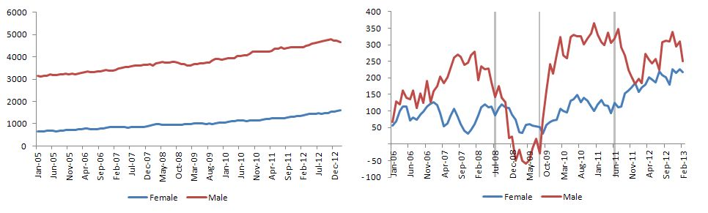

The DiD provided in Figure 2 represents the difference between these two series. In other words, it represents the difference between the annual employment differences for women and annual employment differences for men. What is important is the direction of movement rather than the level of difference in differences. Upward movements in this series indicate relative improvement in employment of women, while downward movements mean relative worsening in the employment of women. For periods where the series moves horizontally, it can be assumed that changes in the employment of men and women move in a parallel manner.

Figure 2 Difference in differences, age group 30-44, formal employment

According to data, there were no major changes in the relative situation of women in the January 2006 - January 2007 period. However, the increases in women's employment between January 2007 and January 2008 lagged behind increases in men’s employment, and the difference in differences series moved against women. After January 2008, there is a rapid improvement in the relative situation of women. This improvement, though arguably starting before July 2008, continued afterwards. In the January- August 2009 period, women's formal payroll employment continued to increase on an annual basis, while losses were recorded in men's employment. Parallel to these developments, the difference in differences series moved to the positive axis.

One of the most important developments here is that the relative improvement seen in formal employment of women abruptly ends in August 2009. It is clear that this rapid decline observed after August 2009 stems from the introduction of new employment incentives that make no distinction based on gender. Payments for the premiums covered under the scope of the incentives for new employment continued until June 2011. One can say that this regulation has almost totally cancelled out the effect of the incentives that rendered the employment of women relatively less costly for employers. As such, the DiD series remained horizontal from August 2009 to June 2011. As the incentive payments granted for new employment came to an end in June 2011, an improvement was recorded again in formal employment of women.

Figure 3 presents the difference in differences, this time for informal employment. In other words, it plots the difference between the annual differences in the number of informally employed women and the annual differences in the number of informally employed men. As seen, the DiD series in the informal labor market moves on a much narrower band. More importantly, no marked movements are observed in the series during the periods when the incentives are introduced and when the effects of the incentives are cancelled out. Based on this comparison, the analysis is based on the formal labor market.

Figure 3 Difference in differences, age group 30-44, informal

expands the DiD analysis for the same age group by studying different sectors. The construction sector was excluded from the analysis due to the traditionally low number of women employed in this sector. The DiD series calculated separately for industry and services sectors explicitly show that the relative improvement in formal payroll employment of women is due to increases in the industrial sector. The DiD series do not vary much before and after the period in which the incentives are effective, yet rapidly improves in the periods when incentives are effective (July 2008 - August 2009, and after June 2011).

Figure 4 Difference in differences by sector, age group 30-44, formal employment

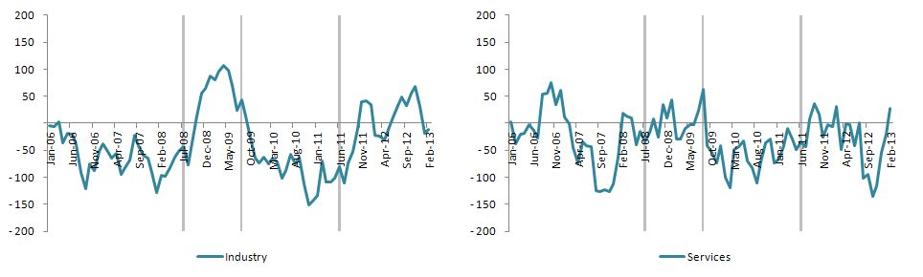

Data show that relative decline in formal employment of women between January 2007 and January 2008 occurred in the services sector. In the second half of 2006, the increase in women's employment is higher than men's in the services sector. However, the formal wage employment of women relatively worsened throughout 2007. In services, the difference in differences advanced in favor of women in early 2008. Although incentives had no visible effects In July 2008, a slight negative effect can be seen after August 2009. There are no significant changes immediately after June 2011.

Figure 5 Difference in differences by professions, age group 30-44, formal employment

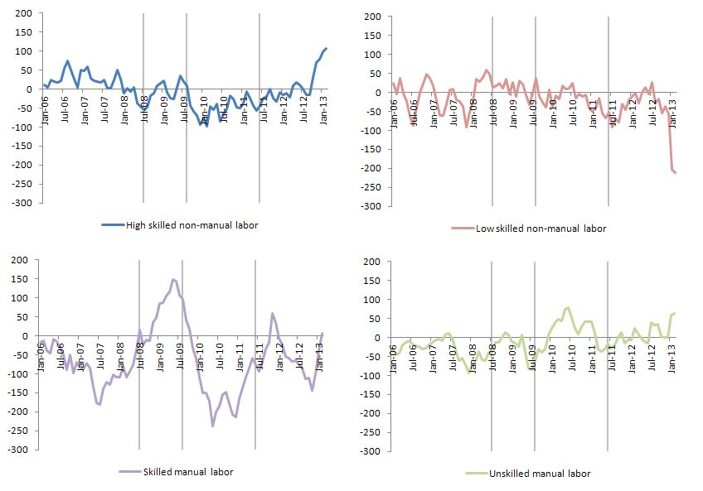

When the DiD analysis is repeated for 4 different professional groups, the results show that both the relative worsening and the relative improvement seen in formal employment of women occurs for those employed in skilled manual labor (Figure 5).[6] There are no obviously visible movements associated with incentives in other professional groups. Similar to the movements in the total formal employment of women, between July 2008 and August 2009, a relative improvement was recorded in formal employment of women in jobs based on manual skills compared to formal employment of men in the same jobs. Later on, formal employment of women in these professional groups relatively declined, though somewhat improved after early 2011.

DiD statistics calculated according to firm sizes are given in Figure 6. Data show that both the relative decline in 2007 and the improvement in the incentive period occurred mainly in companies that employ at least 25 workers and that are generally considered to be large firms in Turkey. On the other hand, the effect of the expansion of incentives to cover all new employment is evident in companies with at least 50 employees. It may be that the small firms fail to benefit from these incentives since: they are not sufficiently informed, they are not familiar with bureaucratic processes, or they insist on creating informal employment for various reasons.

Figure 6 Difference in differences by business sizes, age group 30-44, formal employment

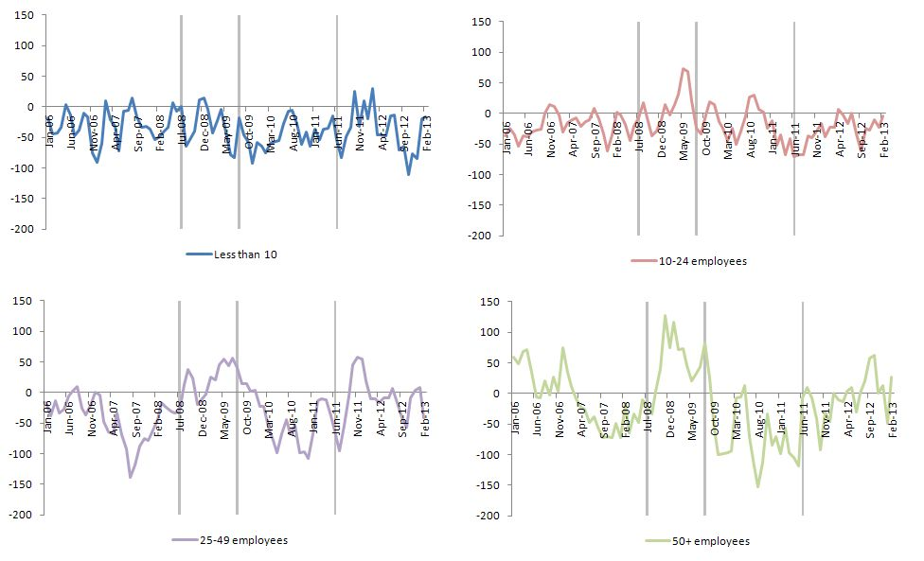

Figure 7 and Figure 8 give the DiD statistics for education and marital statuses of women. When disaggregated by education, incentives seem to be more effective on women who do not hold a high school degree. Between July 2008 and August 2009, an improvement was seen in the formal employment of women with lower than high school education levels compared to men's, yet this improvement was replaced with relative losses in the period after August 2009. Another striking development is the strong relative improvement in the formal employment of women with lower than high school education levels after June 2011.

An improvement can be seen after July 2008 in the employment of women who are high school graduates, though this improvement is not marked. However, what is really remarkable is the sharp decline in August 2009. For graduates of vocational high schools and universities, no incentive-associated movement is observed.

Figure 7 Difference in differences by education, age group 30-44, formal employment

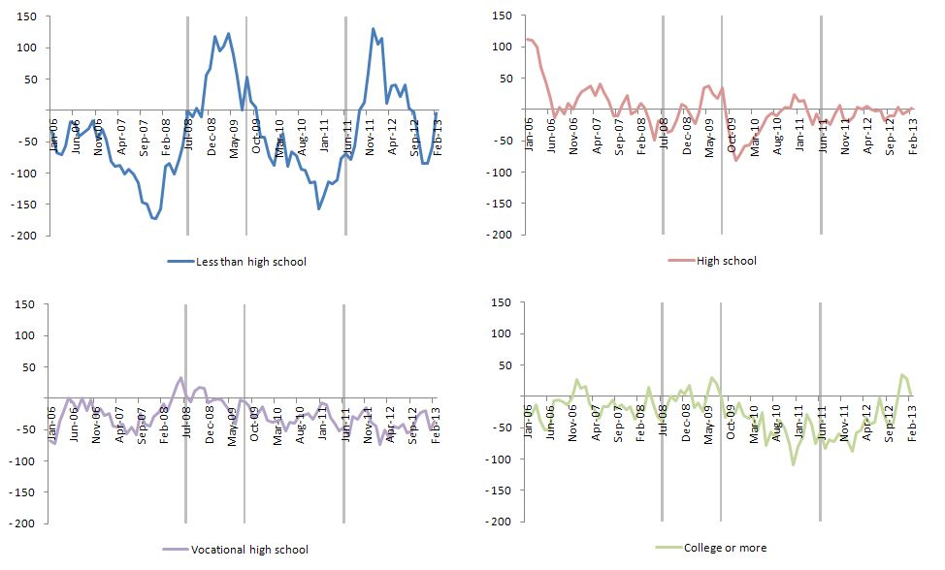

When the DiD statistics are examined according to marital status, it becomes evident that the incentives had a significant effect particularly on the employment of married women (Figure 8). Almost 40% of the formal payroll employment consists of unmarried women. Hence, it is quite surprising how formal employment of women can differentiate so much on the axis of marital status. It is also clearly seen that married women benefit more from the social security premium incentives introduced to increase women's employment.

The low level of women's participation in labor, which is an important structural characteristic of the Turkish labor market, reveals itself as a strong added worker effect in crisis periods.[7] The global economic crisis affected the Turkish labor market particularly in the second half of 2008 and the first half of 2009, and non-farm unemployment rates rapidly increased during that period. However, it was not until 2011 that non-farm unemployment rates were able to return to pre-crisis levels. It is expected that added worker effect will coincide with the period in which the effects of the crisis on the labor market were most strongly felt. DiD statistics also indicate that there were significant improvements in the employment of married women, particularly when the incentives were in effect. Hence, it can be concluded that some of the women entering the labor market due to an added worker effect in this period have benefited from the incentives.

Figure 8 Difference in differences by marital status, age group 30-44, formal employment

Figure 9 shows difference in differences by marital status for formal employment. What is remarkable here is that whether married or not, no significant movements are observed in the informal employment of women compared to men. Both series are horizontal. Although there is some improvement in the informal employment of married women after June 2011, it is difficult to associate this improvement with social security premium incentives.

Figure 9 Difference in differences by marital status, age group 30-44, informal employment

## Conclusion

In order to encourage employment of women and youth in the Turkish labor market, tax incentives were implemented. According to these regulations, employer contribution shares of social security premiums are to be paid by the Unemployment Insurance Fund. The effects of these incentives on the employment of women in the 30-44 age group were studied on multiple axes. Research results show that the incentives were effective on formal employment, as expected.

The incentives were used mostly by relatively large businesses, especially in the industrial sector, in the employment of women in jobs requiring skilled manual labor. In parallel, it is seen that the employment levels of women with education levels lower than high school relatively increased. Another interesting finding is that, with the involvement of the added worker effect in tandem with the global economic crisis, a relative improvement was observed in the formal employment of married women. No evident effects of the incentives can be seen on the employment of unmarried women and on informal employment.

As a conclusion, it is clear that the shouldering of the employer shares of social security premiums by the State had positive effects on women's employment. However, the expansion of similar incentives to all newly employed people regardless of age or gender almost cancelled out the positive effects of the incentives on the employment of women and youth. Policy-makers should take into account all possible interactions between incentives when designing laws and regulations.

1. * Asst. Prof. Dr. Gökçe Uysal, Betam, Assistant Director, [gokce.uysal@bahcesehir.edu.tr](mailto:gokce.uysal@bahcesehir.edu.tr)
2. I would like to thank Murat Karakaş and TurkStat for their help in providing data.
3. The employer contribution shares of social security premiums are paid by the State for six months.
4. In accordance with Law no. 5084, only Adıyaman, Afyon, Ağrı, Aksaray, Amasya, Ardahan, Batman, Bartın, Bayburt, Bingöl, Bitlis, Çankırı, Diyarbakır, Düzce, Erzincan, Erzurum, Giresun, Gümüşhane, Hakkari, Iğdır, Kars, Kırşehir, Malatya, Mardin, Muş, Ordu, Osmaniye, Siirt, Sinop, Sivas, Şanlıurfa, Şırnak, Tokat, Uşak, Van and Yozgat were included within the scope of the incentives; yet, with Law no 5350, 13 more provinces were included in the scope of incentives starting from 01/04/2005, namely Kilis, Tunceli, Kastamonu, Niğde, Kahramanmaraş, Çorum, Artvin, Kütahya, Trabzon, Rize, Elazığ, Karaman and Nevşehir; finally, with Law no. 5568, businesses in Gökçeada and Bozcaada in the province of Çanakkale were also included within the scope of the incentives.
5. Monthly macro data were specifically requested from TurkStat.
6. These professions include those employed in qualified farming, animal husbandry, hunting, forestry and aquatic products and associated jobs, as well as facility and machine operators and assemblers, as specified in ISCO 88.
7. Baslevent C. and O. Onaran, “Are married women in Turkey more likely to become added or discouraged workers?”, Labor, Vol. 7, No.3, 2003.

   Degirmenci S. and I. Ilkkaracan, “Economic crises and the added worker effect in the Turkish labor market”, in *Gender Perspectives and Gender Impacts of the Global Economic Crisis*, ed. R. Antanopoulos, N. Cagatay and S. Hsu, Routledge, (forthcoming) 2013.

   Karaoglan D. and C. Okten, 2012, “Labor force participation of married women in Turkey: Is there an added or discouraged worker effect?”, IZA Discussion Paper No.6616.