

Research Brief 12/130

April 18, 2012

Regional Labor Markets in Turkey
The Evolution of Regional Unemployment and Structural Challenges

Seyfettin Gürsel* ve Ayşenur Acar∗

Executive Summary

Regional unemployment is a poorly documented topic in Turkey. In this research brief, we analyze unemployment in 26 NUTS2 regions in Turkey from 2005 to 2011. Given that agricultural employment varies considerably across regions, we focus on the non-agricultural unemployment. Using regional agricultural and non-agricultural employment data as well as total labor force and unemployment data released by TurkStat, we estimate the number of unemployed persons in non-agricultural sectors and the non- agricultural unemployment rate.

Non-agricultural unemployment rates vary by more than twofold across regions in Turkey. Very generally, we can say that unemployment is lower in the West than in the East. Manisa, Balıkesir and Bursa regions have the lowest unemployment rates in 2011. On the contrary, Ağrı, Van and Gaziantep regions have the highest unemployment rates. However, there are also regions with high unemployment rates in the West regions with low unemployment rates in the East. For example, İzmir and Kocaeli, which are two developed regions compared to the rest of Turkey, have non-agricultural unemployment rates above Turkey’s average. The underlying cause is high increases in labor force due to the high levels of migration to these regions.

The evolution of regional unemployment is also different across regions. The overall unemployment rate slightly declined in the period of 2005-11 while unemployment rate decreased in 12 regions and increased in the remaining 14 regions. The largest declines in unemployment rates in the last six years were in Malatya, Adana, Kırıkkale and Ankara regions. Ağrı, Antalya, Van and Zonguldak were the regions with the highest increase in unemployment rates. Zonguldak was the only region with a decline in non-agricultural employment, albeit limited, in the last six years. Clearly, Zonguldak is facing serious economic challenges. Note that increase in non-agricultural employment in Antalya was significantly below average as well.

The findings indicate that regional unemployment has very different dynamics. Regions where unemployment rate decreased due to strong increase in employment (Balanced Developing Regions) are situated on the North-South axis in Middle Anatolia and Middle-East Anatolia. Regions where unemployment rate decreased due to weak increases in employment coupled with even weaker increases in labor force (Cooling Regions) cluster around North West Anatolia and Middle Black Sea Region. Regions where strong increases in employment were subdued by stronger increases in labor force and thus unemployment increased (Regions under pressure) are located in East and South East (intra-regional migration). Industrialized regions like Tekirdağ, İzmir and Kocaeli (inter-regional migration) are also in this category.

Unemployment is generally lower in the West, higher in the East
But with surprising exceptions

We usually follow unemployment rates at the national level. However, unemployment rates differ through regions. If we look at NUTS2 level compassing 26 regions, we see that the difference between the highest and the lowest unemployment rates across regions can be as large as twofold. Differences in regional unemployment rates point to important structural differences across regions. Moreover, they are also a sizeable ingredient of regional economic inequality.

The non-agricultural unemployment rate instead of the overall unemployment rate is a more relevant statistic for the study of regional unemployment in Turkey as the agricultural employment is still high and varies tremendously from one region to other. On the other hand, agricultural production is still dominantly done by family farms, implying an unemployment rate of almost zero in agriculture, distorting the overall unemployment rate in a region. In other words, a high share of agricultural employment in total employment in a region may cause a low unemployment rate, ceteris paribus. In 2011, the difference between non-agricultural unemployment rate and overall unemployment rate was the highest at 10.2 percentage points in Ağrı, 6-7 percentage points in Van, Trabzon and Kastamonu (See App. Figure 2 and App. Table 1). There is a high correlation (86.8 percent, See App. Figure 1) between the share of agricultural employment in total employment and the difference between non-agricultural unemployment rate and total unemployment rate. This indicates the strong effect of agricultural employment on unemployment.

In this context, non-agricultural unemployment rate provides a clearer picture of regional unemployment. TurkStat releases regional agricultural and non-agricultural employment data; however it does not release non-agricultural labor force and unemployment series. We estimate non-agricultural regional labor force and the non-agricultural unemployment series (App. Table 1 and 2).

Map 1 shows the regional variation in non-agricultural unemployment in 2011. Regions colored with light red in the map have the lowest non-agricultural unemployment rate. Hence, 4 regions with the lowest unemployment rate are presented as follows, respectively: Manisa (8.3 percent) Balıkesir (Balıkesir, Çanakkale) (8.4 percent), Bursa (Bursa, Eskişehir, Bilecik) (8.6 percent) and Samsun (Samsun, Tokat, Çorum, Amasya) (9.3 percent) (App Figure 2 and App Table 1). As clearly seen in the map, except for Samsun, these regions are in Western Turkey and are among the developed regions. However, İzmir, which is the second largest city in Western Turkey, has a very high unemployment rate; 16.5 percent. Unemployment rate in Kocaeli region (14.7 percent), which is one of the most industrialized regions, is above average (13.2 percent). These findings show that the size of the labor force, thus migration, as well as employment levels affect unemployment. Note that Ankara region (Ankara is the Capital) is below average (9.9 percent) due to both a high industrialization level and a large number of public employees.
Map 1: Regional unemployment rates (2011)
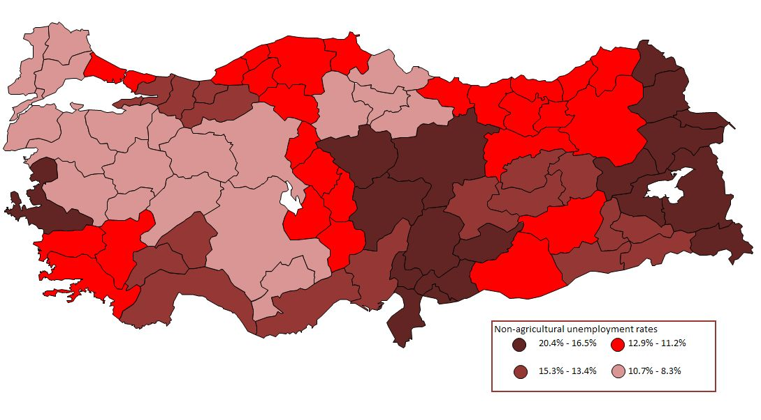
Source: Household Labor Force Survey released by TurkStat; BETAM

4 regions with the highest unemployment rates are as follows: Ağrı (20.4 percent), Van (19.4 percent), Gaziantep (Gaziantep, Adıyaman, Kilis) (17.8 percent) ve Hatay (Hatay, Kahramanmaraş, Osmaniye) (17.2 percent). It is not surprising that Van and Ağrı are among the regions with the highest unemployment rates. However, high unemployment rates in Gaziantep and Hatay, which are quite developed and industrialized regions, are unexpected.

There are other unexpected findings in the data. We present two typical examples: Kayseri (Kayseri, Sivas, and Yozgat) and Şanlıurfa (Şanlıurfa, Diyarbakır). While Kayseri is industrialized above Turkey’s average, non-agricultural unemployment rate in the region (16.7 percent) is also well above Turkey’s average (13.2 percent). On the other hand, Şanlıurfa is not a leading region in terms of industrialization, but it has a low non-agricultural unemployment level (11.2 percent). What are the possible causes of these findings? First reason that comes to mind is diversity of provinces within each region in terms of development and employment levels. For example, while Kayseri is developed above Turkey’s average, Sivas and Yozgat are not.

We cannot calculate approximate values of non-agricultural unemployment at the provincial level since TurkStat does not release agricultural and non-agricultural data series at this level in Turkey. However, estimated provincial general unemployment data series released by TURKSTAT in 2010 gives an idea (TurkStat 2010, Main Labor Force Indicators by Province) . While general unemployment rate was estimated as 14.1 percent in Kayseri, this rate was 13.6 and 12.7 percent in Sivas and Yozgat, respectively. It is obvious that high unemployment rates in Sivas and Yozgat are not the source of the high unemployment rate in the Kayseri region. Also, low unemployment rate in the Şanlıurfa region cannot be explained by low unemployment in Diyarbakır. According to estimations released by TURKSTAT in 2010, total unemployment rate in Şanlıurfa is 12.4 percent, while it is 13.5 percent in Diyarbakır. The difference is negligible. Hence, the migration to and from regions should be considered in any analysis investigating regional unemployment.

Unemployment: regions where it increased, regions where it decreased
Unemployment boom in South West of Turkey

Changes in regional unemployment from 2005 to 2011 are presented in Map 2: Regions colored with blue and its shades represent regions where unemployment decreased, while regions colored with red and its shades represent regions where unemployment increased (Note that darker colors correspond to larger increase or decrease in unemployment rate). While unemployment rate decreased in 12 regions of 26 NUTS2 regions from 2005 to 2011, it increased in the remaining 14 regions (See Map 2 and App. Figure 3). In the period we consider, average non-agricultural unemployment rate decreased from 14.3 percent to 13.2 percent. 5 regions with the highest decreases in non-agricultural unemployment rate are as follows: Malatya (Malatya, Elazığ, Bingöl, Tunceli) (from 27.3 percent to 15.3 percent), Adana (Adana, Mersin) (from 22.3 percent to 14.7 percent), Kırıkkale (Kırıkkale, Aksaray, Niğde, Nevşehir, Kırşehir) (from 17.8 percent to 11.9 percent ), Ankara (from 15.1 percent to 9.9 percent); 5 regions with highest increases in non-agricultural unemployment rate are presented as follows, respectively: Ağrı (from 8.3 percent to 20.4 percent), Antalya (Antalya, Isparta, Burdur) (from 8.3 percent to 13.4 percent), Van (from 16.1 percent to 19.4 percent), Zonguldak (Zonguldak, Karabük, Bartın) (from 10.5 percent to 12.5 percent) and Aydın (Aydın, Denizli, Muğla) (from 11 percent to 12.9 percent) (See App Table 1 and 3).

Out of 12 regions where non-agricultural unemployment rate decreased, employment increased strongly (above average) in 8 regions and relatively in 3 regions (close to average). Although there have been strong and relatively strong increases in labor force in these regions, we observe a decline in unemployment since these increases stayed below the employment increases. The largest increase in non-agricultural employment was in Malatya (47.5 percent) (App Table 2 and 3). However, as the labor force increased only by 26.6 percent, which was quite above average (19 percent) a record decline occurred in unemployment: 44 percent (App Table 3). We observe similar patterns in 3 regions in which unemployment decreased significantly (Adana, Kırıkkale and Ankara), (See App Table 2 and 3).

In the 5 regions where unemployment increases were sizeable, very different patterns emerge: Ağrı region is an exception due to a base effect (see foot note 10) as the non-agricultural labor force and employment are at very low levels. The second highest increase in non-agricultural unemployment was in Antalya region where the increase in unemployment was due to both a large increase in non-agricultural labor force (18.9 percent) and a relatively low increase in employment (12.3 percent) (See App. Table 3). In Aydın region unemployment increased despite a high raise of employment (18.2 percent, See App Table 3) because labor force increased more rapidly: 20.8 percent. Note that Antalya and Aydın regions, in South West of Turkey, are important recipients of migration from East and South East of Turkey; in the last six years, the regions could not create enough employment to absorb migrants. We should also keep in mind the difficulties the Kurdish migrants face in the labor market such as low human capital endowments and discrimination, which may increase unemployment rates in these regions.

Map 2: Change in regional NA unemployment rates from 2005 to 2011
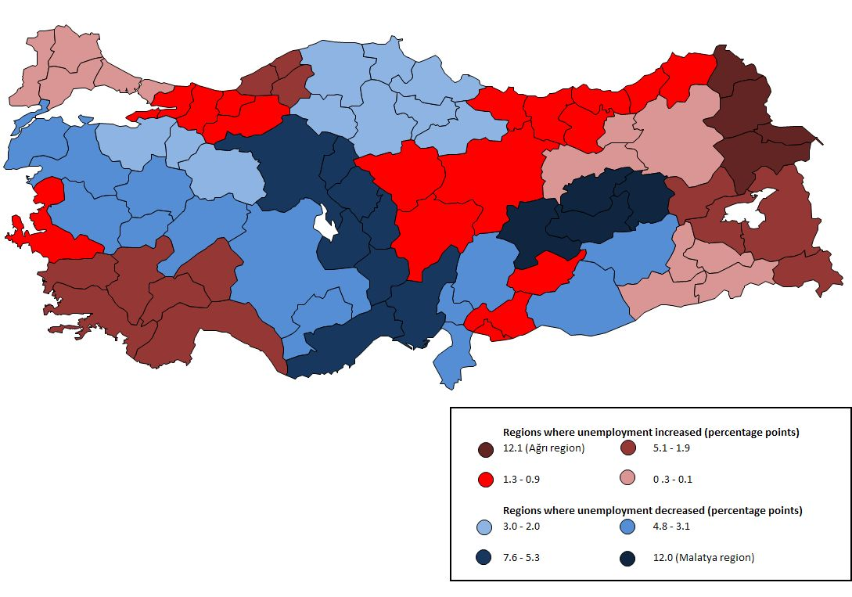
Source: Household Labor Force Survey released by TurkStat; BETAM

The causes of unemployment increases in Van and Zonguldak differ from Antalya and Aydın. Most prominent cause of the increase in unemployment in Van region is migration from rural to urban areas within the region. There was a tremendous increase in non-agricultural labor force in this region from 2005 to 2011: 79 percent. It is not difficult to see that the main reason of high increase in non-agricultural labor force is the migration from rural to urban areas given that this region a source of migration. In the period we analyzed, while overall agricultural employment in Turkey increased by 19.2 percent, the fact that it remained 7.7 percent in Van shows that the migration from rural to urban areas was strong. (See App Table 4). Therefore, unemployment in Van increased despite a large increase in non-agricultural employment (72 percent). On the other hand, main factor behind the increase in unemployment in Zonguldak region has been the decline in non-agricultural employment. Zonguldak is the unique region with a slight decrease in non-agricultural employment from 2005 to 2011: -0.4 percent. Increase in non-agricultural labor force was low (1.9 percent), but enough to increase unemployment. The region experienced out-migration since it could not create employment.

Regional Labor Markets Dynamics

Findings above show that there are different dynamics in regional labor markets. Changes in unemployment are basically due to changes in employment and in labor force. These two variables can move in the same direction as well as in reverse. As expected, non-agricultural employment and labor force increased together during the period considered, except for the crisis period. However, each region experienced different magnitudes of increases in employment and labor force. Consequently, unemployment increased or decreased according to the relative magnitudes of these increases.

Non-agricultural employment increased in 25 regions, Zonguldak was the only exception. However, the increases vary from 3 percent (Trabzon region) to 72 percent (Van region). Increases in non-agricultural employment substantially depend on regional GDP growth and on the employment elasticity of growth. Unfortunately, TurkStat has not release regional GDP series since 2008.

Non-agricultural employment increased annually by 3.4 percent in Turkey from 2005 to 2011; this corresponds to a 20.5 percent cumulative increase. Note that increases in 15 regions are above this average (See App. Table 3). However, increases in employment may not be enough to decrease regional unemployment. The increase of non-agricultural labor force matters. We observe that non-agricultural labor force increased annually 3.2 percent in Turkey from 2005 to 2011, which corresponds to a 19 percent cumulative increase. Note that the increase of non agricultural labor force in 13 regions is above this average.

There are three basic driving factors behind the increase in non-agricultural labor force: Population increase, increase in female labor force participation and migration. We do not think that regional variations in population increases are large enough to cause regional differences in unemployment rates. Regional female labor force participation rates in urban areas have not been documented yet. Migration seems to have played an important role given that some regions experienced increases in non-agricultural unemployment even when they had sizeable increases in non-agricultural employment. This must be due to large increases in labor force due to migration. Van and Aydın are examples in this regard. As stated above, unemployment increased significantly in these two regions despite high increases in employment. Note that increase in labor force in Van (78.9 percent) region was due to rural to urban migration in the region, while the increase in Aydın region (20.8 percent) was due to in-migration.

We think that 26 regions can be clustered in 4 subgroups taking into consideration the particularities of regional labor market dynamics, at the expense of losing important nuances. The first group comprises the regions where unemployment decreased due to large increases in non agricultural employment despite sizable increases in labor force in the same time. We call them as “Balanced Developing Regions” (green colored regions in Map 3). The second group contains the regions where unemployment also decreased due to small increases in non agricultural employment but even smaller increases in labor force. We call them as “Cooling Regions” (blue colored regions in Map 3). The third group includes the regions where unemployment increased due to relatively large increases in non-agricultural employment but even larger increases in labor force. We call them as “Regions under Pressure” (yellow colored regions in Map 3). Finally, the fourth group compasses the regions where unemployment rates increased due to small increases in employment with rather large increases in labor force. We call them as “Regions in Critical State” (red colored regions in Map 3).

Map 3: Regional classification of NA unemployment rates (2005-2011)
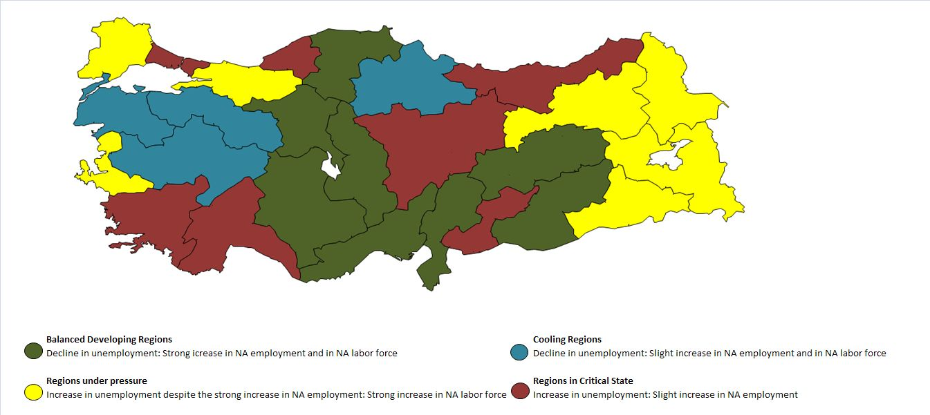
Source: Household Labor Force Survey released by TurkStat; BETAM

Balanced Developing Regions (green) are mostly located in Middle Anatolia. Malatya, Kırıkkale, Ankara and Şanlıurfa are most prominent regions of this group. Except for Samsun, Cooling Regions (blue) are located in North West of Anatolia: Balıkesir, Bursa and Manisa regions. We observe that increases in employment (industrialization) have been saturated in these regions. Also, one can observe that the labor markets are not pressured by migration. Regions under Pressure (yellow) can be classified under two sub-groups: Industrialized regions of Western regions and the underdeveloped East. In the three industrialized regions (İzmir, Kocaeli and Tekirdağ) large increases of labor force, mainly driven by migration from East, played an important role in the raise of unemployment. In the Eastern regions the large increases in non-agricultural labor force are mostly caused by intra-regional migration from rural to urban areas. Regarding the Regions in Critical State (red), we observe that they are distributed evenly across Turkey. İstanbul and South West (Antalya and Aydın), among the most developed regions, are in this group. Increase in unemployment rate in Istanbul has been only 2.3 percent, which indicates that İstanbul is very close to Balanced Developing Regions while Antalya, with an increase of 62 percent in unemployment rate, is in a desperate situation. As stated above, Antalya region has been very far from creating enough jobs to fight migration pressures. Increases both in employment and labor force in East Black Sea have been too low. The region cannot create enough employment and is exporting part of its labor force. Unexpectedly, Kayseri region, quite industrialized, shows similar patterns; increases in employment and in labor force are too small. These two last regions experienced slightly increases in unemployment; they are close to Cooling Regions.

The situation of Gaziantep region is very exceptional. From 2005 to 2011 non-agricultural employment increased by 17.7 percent, which is close to average, while labor force increased by 22.8 percent. However the increase of employment (31 percent) occurred in full after 2007 when exports to Middle East started to boom. Until then non-agricultural employment decreased in this region (App. tables 2 and 3). So, Gaziantep region would be clearly belonging to Balanced Developing Regions during the period from 2007 to 2011.

Policy Recommendations

Evaluation of unemployment at the regional level shows that regional labor market dynamics are important in understanding and fighting unemployment. It is clear that more research is needed regarding the interplay between regional economic growth and employment as well as migration dynamics. We believe that cooperation between regional development agencies and researchers will be very productive in regional policies. Considering the findings of this research brief, let us suggest some policy recommendations at the regional level.

- Investment incentive framework recently announced should be reconsidered in regions characterized by low increases in non-agricultural employment. Some regions, despite their low capacity of job creation in non-agricultural sectors have been positioned in relatively developed regions. In this context, Zonguldak region is a striking example. While non agricultural employment decreased in this region, the three provinces forming it are classified as 3rd and 4th level regions regarding investment incentives, which place them as relatively developed regions.

- The determinants of intra-regional migration motivations such as terrorism and structural problems in agriculture should be well understood in order to design appropriate policies.

- Active labor market policies should be designed to help unemployed migrants find jobs in the developed regions of Western Turkey, like İzmir, Antalya, Aydın, Kocaeli etc.

- The impact of exports to neighborhood countries on employment is very important. Gaziantep and Mardin regions are typical examples. In these two regions, while non-agricultural employment has been decreasing until 2007, it is significantly increasing since 2007. So, opening the border with Armenia and developing frontier trading with Iran should be included on the political agenda.

App Fig 1: Correlation coefficient between the share of agricultural employment in total employment and the difference between NA unemployment rate and unemployment rate
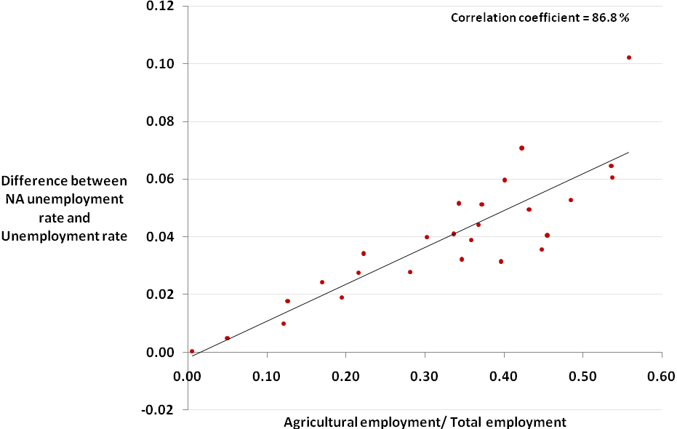
Source: Household Labor Force Survey released by TurkStat; BETAM

App Fig 2: Regional unemployment rates (2011)
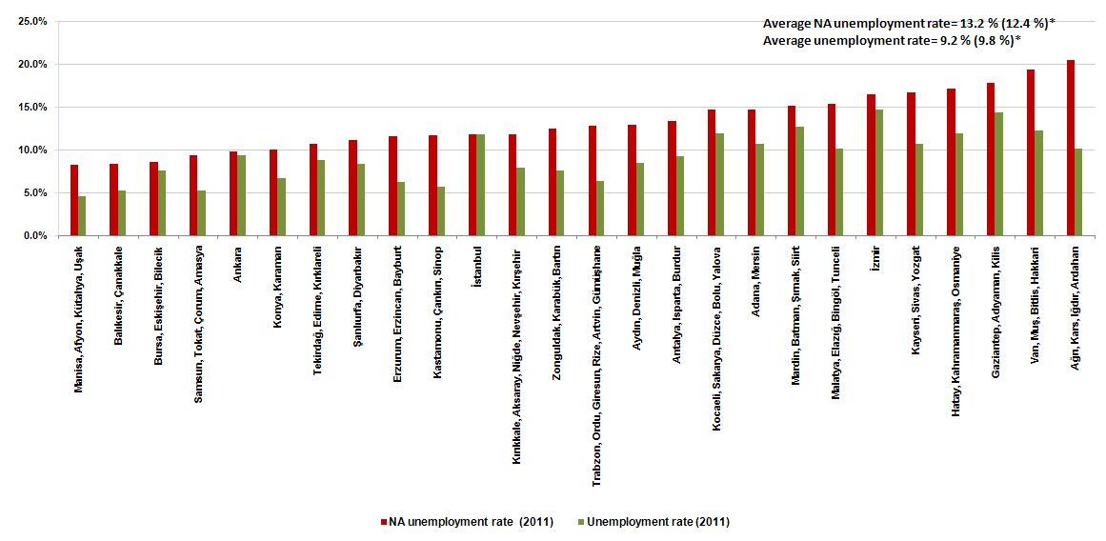
Source: Household Labor Force Survey released by TurkStat; BETAM
* Numbers in the brackets are weighted averages released by TurkStat. Hence, they are slightly different from Betam’s calculation.
App Fig 3: Change in regional NA unemployment rates from 2005 to 2011 (in percentage points)
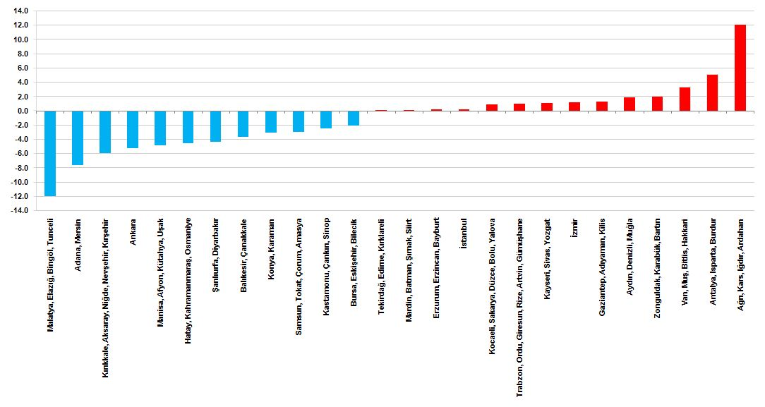
Source: Household Labor Force Survey released by TurkStat; BETAM

App Fig 4: Rate of net regional migration from 2008 to 2011 (%)
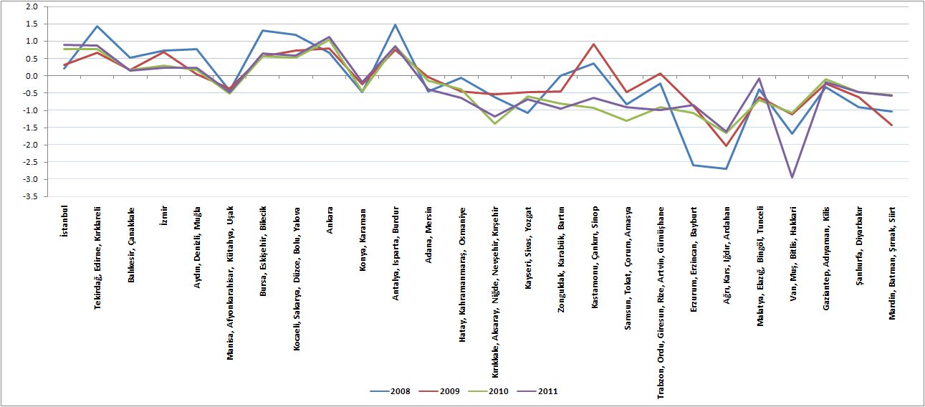Source: Internal Migration Statistics released by TurkStat

App Table 1: Unemployment rates by NUTS2 regions
NUTS2 Regions | Unemployment rate (%) |  |  |  |  |  |  | NA Unemployment rate (%)
NUTS2 Regions | 2005 | 2006 | 2007 | 2008 | 2009 | 2010 | 2011 | 2005 | 2006 | 2007 | 2008 | 2009 | 2010 | 2011
TR10 (İstanbul) | 11.5 | 11.4 | 10.4 | 11.2 | 16.8 | 14.3 | 11.8 | 11.6 | 11.4 | 10.4 | 11.2 | 16.9 | 14.3 | 11.8
TR21 (Tekirdağ, Edirne, Kırklareli) | 8.1 | 8.3 | 7.8 | 11.2 | 13.0 | 9.8 | 8.8 | 10.6 | 10.2 | 9.6 | 13.7 | 16.2 | 12.2 | 10.7
TR22 (Balıkesir, Çanakkale) | 6.8 | 6.2 | 5.5 | 7.5 | 8.5 | 7.7 | 5.3 | 12.1 | 11.1 | 9.7 | 11.5 | 13.4 | 12.1 | 8.4
TR31 (İzmir) | 13.9 | 12.0 | 10.5 | 11.8 | 16.2 | 15.1 | 14.7 | 15.3 | 13.3 | 11.5 | 12.6 | 17.5 | 16.7 | 16.5
TR32 (Aydın, Denizli, Muğla) | 7.3 | 7.7 | 9.9 | 10.8 | 14.2 | 11.9 | 8.5 | 11.0 | 11.1 | 13.3 | 14.2 | 18.7 | 16.7 | 12.9
TR33 (Manisa, Afyon, Kütahya, Uşak) | 8.1 | 7.4 | 7.3 | 8.3 | 11.0 | 7.6 | 4.7 | 13.1 | 11.5 | 11.0 | 12.3 | 16.9 | 12.0 | 8.3
TR41 (Bursa, Eskişehir, Bilecik) | 9.2 | 8.0 | 8.1 | 10.3 | 13.9 | 10.1 | 7.6 | 10.6 | 9.3 | 9.4 | 11.7 | 15.5 | 11.2 | 8.6
TR42 (Kocaeli, Sakarya, Düzce, Bolu, Yalova) | 12.2 | 11.7 | 11.6 | 10.8 | 15.0 | 13.0 | 11.9 | 13.8 | 13.3 | 13.4 | 12.8 | 18.1 | 15.8 | 14.7
TR51 (Ankara) | 14.7 | 12.7 | 11.5 | 11.8 | 13.6 | 12.1 | 9.4 | 15.1 | 13.1 | 11.9 | 12.0 | 13.8 | 12.5 | 9.9
TR52 (Konya, Karaman) | 9.7 | 11.3 | 10.6 | 10.2 | 10.1 | 8.4 | 6.8 | 13.1 | 15.1 | 14.4 | 14.6 | 14.2 | 12.4 | 10.0
TR61 (Antalya, Isparta, Burdur) | 6.5 | 7.7 | 7.0 | 8.9 | 11.4 | 10.7 | 9.3 | 8.3 | 10.4 | 9.9 | 13.0 | 16.3 | 15.3 | 13.4
TR62 (Adana, Mersin) | 18.4 | 16.9 | 15.7 | 16.8 | 22.0 | 16.7 | 10.7 | 22.3 | 20.6 | 19.6 | 21.2 | 28.4 | 22.3 | 14.7
TR63 (Hatay, Kahramanmaraş, Osmaniye) | 15.7 | 12.2 | 12.4 | 15.8 | 18.0 | 13.6 | 12.0 | 21.7 | 16.9 | 16.9 | 21.0 | 24.1 | 19.6 | 17.2
TR71 (Kırıkkale, Aksaray, Niğde, Nevşehir, Kırşehir ) | 10.5 | 10.4 | 9.5 | 10.1 | 14.9 | 10.1 | 8.0 | 17.8 | 16.4 | 14.3 | 13.6 | 21.2 | 15.5 | 11.9
TR72 (Kayseri, Sivas, Yozgat) | 11.4 | 11.5 | 11.6 | 11.4 | 13.2 | 13.7 | 10.7 | 15.6 | 14.3 | 15.2 | 15.1 | 17.2 | 18.3 | 16.7
TR81 (Zonguldak, Karabük, Bartın) | 7.2 | 6.0 | 8.4 | 6.9 | 7.3 | 10.8 | 7.6 | 10.5 | 8.7 | 13.1 | 12.1 | 13.5 | 17.0 | 12.5
TR82 (Kastamonu, Çankırı, Sinop) | 8.6 | 5.0 | 4.2 | 6.7 | 9.4 | 8.3 | 5.7 | 14.2 | 11.3 | 8.3 | 12.0 | 15.4 | 15.0 | 11.8
TR83 (Samsun, Tokat, Çorum, Amasya) | 6.2 | 7.2 | 8.7 | 7.4 | 6.9 | 7.2 | 5.3 | 12.3 | 12.8 | 14.9 | 13.8 | 13.4 | 12.4 | 9.3
TR90 (Trabzon, Ordu, Giresun, Rize, Artvin, Gümüşhane) | 5.5 | 5.6 | 6.6 | 5.8 | 6.0 | 6.1 | 6.4 | 11.9 | 11.2 | 12.4 | 11.2 | 12.4 | 12.5 | 12.9
TRA1 (Erzurum, Erzincan, Bayburt) | 4.3 | 5.0 | 5.7 | 6.3 | 7.7 | 6.2 | 6.3 | 11.3 | 9.6 | 9.8 | 11.9 | 14.9 | 13.5 | 11.6
TRA2 (Ağrı, Kars, Iğdır, Ardahan) | 3.3 | 5.1 | 6.0 | 5.6 | 9.4 | 10.3 | 10.2 | 8.3 | 11.0 | 15.4 | 16.8 | 22.7 | 21.6 | 20.4
TRB1 (Malatya, Elazığ, Bingöl, Tunceli) | 18.8 | 14.1 | 13.2 | 14.5 | 16.8 | 11.9 | 10.2 | 27.3 | 22.0 | 20.5 | 20.2 | 24.2 | 19.2 | 15.3
TRB2 (Van, Muş, Bitlis, Hakkari) | 8.2 | 7.8 | 12.4 | 14.2 | 16.4 | 17.0 | 12.3 | 16.1 | 15.9 | 20.9 | 20.3 | 23.8 | 24.9 | 19.4
TRC1 (Gaziantep, Adıyaman, Kilis) | 13.8 | 15.2 | 18.0 | 16.4 | 17.2 | 12.1 | 14.4 | 16.5 | 18.3 | 23.0 | 22.4 | 21.5 | 15.3 | 17.8
TRC2 (Şanlıurfa, Diyarbakır) | 10.9 | 12.1 | 13.8 | 14.1 | 18.8 | 13.1 | 8.4 | 15.5 | 15.6 | 17.5 | 19.7 | 24.6 | 17.1 | 11.2
TRC3 (Mardin, Batman, Şırnak, Siirt) | 11.1 | 15.7 | 19.9 | 17.4 | 15.1 | 11.8 | 12.7 | 15.0 | 18.8 | 24.5 | 21.9 | 18.6 | 15.8 | 15.1
Overall unemployment rate (TurkStat) | 10.6 | 10.2 | 10.3 | 11.0 | 14.0 | 11.9 | 9.8 | 13.5 | 12.7 | 12.6 | 13.6 | 17.4 | 14.8 | 12.4
Average unemployment rate (Betam) |  |  |  |  |  |  |  | 14.3 | 13.6 | 14.3 | 15.1 | 18.2 | 15.8 | 13.2
Source: Household Labor Force Survey released by TurkStat; BETAM

App Table 2: Regional Non-agricultural (NA) employment and labor force levels
NUTS2 Regions | NA Employment |  |  |  |  |  |  | NA Labor Force
NUTS2 Regions | 2005 | 2006 | 2007 | 2008 | 2009 | 2010 | 2011 | 2005 | 2006 | 2007 | 2008 | 2009 | 2010 | 2011
TR10 (İstanbul) | 3693 | 3794 | 3835 | 3909 | 3715 | 3931 | 4189 | 4176 | 4281 | 4282 | 4402 | 4468 | 4588 | 4751
TR21 (Tekirdağ, Edirne, Kırklareli) | 396 | 414 | 414 | 434 | 435 | 461 | 509 | 443 | 461 | 458 | 503 | 519 | 525 | 570
TR22 (Balıkesir, Çanakkale) | 298 | 288 | 326 | 340 | 336 | 342 | 347 | 339 | 324 | 361 | 384 | 388 | 389 | 379
TR31 (İzmir) | 946 | 987 | 1091 | 1083 | 1070 | 1150 | 1232 | 1117 | 1138 | 1233 | 1239 | 1297 | 1381 | 1475
TR32 (Aydın, Denizli, Muğla) | 582 | 601 | 620 | 652 | 689 | 681 | 688 | 654 | 676 | 715 | 760 | 847 | 818 | 790
TR33 (Manisa, Afyon, Kütahya, Uşak) | 546 | 592 | 577 | 564 | 532 | 577 | 589 | 628 | 669 | 648 | 643 | 640 | 656 | 642
TR41 (Bursa, Eskişehir, Bilecik) | 944 | 953 | 961 | 999 | 979 | 1014 | 1087 | 1056 | 1051 | 1061 | 1131 | 1158 | 1142 | 1189
TR42 (Kocaeli, Sakarya, Düzce, Bolu, Yalova) | 696 | 745 | 756 | 800 | 785 | 844 | 949 | 807 | 859 | 873 | 917 | 958 | 1002 | 1112
TR51 (Ankara) | 1171 | 1238 | 1291 | 1325 | 1319 | 1388 | 1468 | 1380 | 1425 | 1465 | 1506 | 1531 | 1586 | 1629
TR52 (Konya, Karaman) | 398 | 411 | 441 | 486 | 507 | 487 | 485 | 458 | 484 | 515 | 569 | 591 | 556 | 539
TR61 (Antalya, Isparta, Burdur) | 610 | 628 | 637 | 625 | 614 | 655 | 685 | 665 | 701 | 707 | 718 | 734 | 773 | 791
TR62 (Adana, Mersin) | 701 | 750 | 781 | 750 | 747 | 818 | 866 | 902 | 945 | 971 | 952 | 1044 | 1053 | 1015
TR63 (Hatay, Kahramanmaraş, Osmaniye) | 473 | 487 | 493 | 515 | 507 | 547 | 584 | 604 | 586 | 593 | 652 | 668 | 680 | 705
TR71 (Kırıkkale, Aksaray, Niğde, Nevşehir, Kırşehir ) | 226 | 249 | 258 | 261 | 264 | 277 | 304 | 275 | 298 | 301 | 302 | 335 | 328 | 345
TR72 (Kayseri, Sivas, Yozgat) | 412 | 424 | 423 | 409 | 425 | 445 | 445 | 488 | 495 | 499 | 482 | 513 | 545 | 534
TR81 (Zonguldak, Karabük, Bartın) | 238 | 241 | 218 | 210 | 212 | 224 | 237 | 266 | 264 | 251 | 239 | 245 | 270 | 271
TR82 (Kastamonu, Çankırı, Sinop) | 109 | 118 | 122 | 139 | 148 | 147 | 150 | 127 | 133 | 133 | 158 | 175 | 173 | 170
TR83 (Samsun, Tokat, Çorum, Amasya) | 462 | 505 | 542 | 507 | 486 | 508 | 543 | 527 | 579 | 637 | 588 | 561 | 580 | 599
TR90 (Trabzon, Ordu, Giresun, Rize, Artvin, Gümüşhane) | 467 | 494 | 500 | 524 | 488 | 470 | 481 | 530 | 556 | 571 | 590 | 557 | 537 | 552
TRA1 (Erzurum, Erzincan, Bayburt) | 125 | 160 | 166 | 170 | 160 | 154 | 168 | 141 | 177 | 184 | 193 | 188 | 178 | 190
TRA2 (Ağrı, Kars, Iğdır, Ardahan) | 121 | 130 | 104 | 94 | 109 | 127 | 152 | 132 | 146 | 123 | 113 | 141 | 162 | 191
TRB1 (Malatya, Elazığ, Bingöl, Tunceli) | 221 | 234 | 245 | 276 | 276 | 277 | 326 | 304 | 300 | 308 | 346 | 364 | 343 | 385
TRB2 (Van, Muş, Bitlis, Hakkari) | 167 | 169 | 201 | 239 | 247 | 256 | 287 | 199 | 201 | 254 | 300 | 324 | 341 | 356
TRC1 (Gaziantep, Adıyaman, Kilis) | 384 | 357 | 345 | 360 | 401 | 464 | 452 | 460 | 437 | 448 | 464 | 511 | 548 | 550
TRC2 (Şanlıurfa, Diyarbakır) | 317 | 336 | 334 | 309 | 359 | 406 | 437 | 375 | 398 | 405 | 385 | 476 | 490 | 492
TRC3 (Mardin, Batman, Şırnak, Siirt) | 210 | 208 | 191 | 196 | 228 | 266 | 303 | 247 | 256 | 253 | 251 | 280 | 316 | 357
Overall (TurkStat) | 14913 | 15516 | 15871 | 16178 | 16037 | 16911 | 17967 | 17240 | 17773 | 18159 | 18725 | 19415 | 19849 | 20510
Average (Betam) | 14913 | 15513 | 15872 | 16176 | 16038 | 16916 | 17963 | 17300 | 17840 | 18249 | 18787 | 19513 | 19960 | 20579
Source: Household Labor Force Survey released by TurkStat; BETAM

App Table 3: Change in regional labor force series
NUTS2 Regions | Unemployment rate (%) |  |  |  | NA Unemployment rate (%) |  |  |  | NA Employment (%) |  |  |  | NA Labor Force (%)
NUTS2 Regions | 2005-11 | 2005-07 | 2007-09 | 2009-11 | 2005-11 | 2005-07 | 2007-09 | 2009-11 | 2005-11 | 2005-07 | 2007-09 | 2009-11 | 2005-11 | 2005-07 | 2007-09 | 2009-11
TR10 (İstanbul) | 2.6 | -9.6 | 61.5 | -29.8 | 2.3 | -9.7 | 61.4 | -29.8 | 13.4 | 3.8 | -3.1 | 12.8 | 13.8 | 2.5 | 4.3 | 6.3
TR21 (Tekirdağ, Edirne, Kırklareli) | 8.6 | -3.7 | 66.7 | -32.3 | 0.9 | -9.4 | 68.5 | -33.9 | 28.5 | 4.5 | 5.1 | 17.0 | 28.7 | 3.4 | 13.3 | 9.8
TR22 (Balıkesir, Çanakkale) | -22.1 | -19.1 | 54.5 | -37.6 | -30.2 | -19.8 | 38.2 | -37.0 | 16.4 | 9.4 | 3.1 | 3.3 | 11.8 | 6.5 | 7.5 | -2.3
TR31 (İzmir) | 5.8 | -24.5 | 54.3 | -9.3 | 7.6 | -24.8 | 52.0 | -5.9 | 30.2 | 15.3 | -1.9 | 15.1 | 32.1 | 10.4 | 5.2 | 13.7
TR32 (Aydın, Denizli, Muğla) | 16.4 | 35.6 | 43.4 | -40.1 | 17.3 | 20.7 | 40.4 | -30.8 | 18.2 | 6.5 | 11.1 | -0.1 | 20.8 | 9.3 | 18.5 | -6.7
TR33 (Manisa, Afyon, Kütahya, Uşak) | -42.0 | -9.9 | 50.7 | -57.3 | -36.8 | -16.1 | 54.0 | -51.1 | 7.9 | 5.7 | -7.8 | 10.7 | 2.2 | 3.2 | -1.2 | 0.3
TR41 (Bursa, Eskişehir, Bilecik) | -17.4 | -12.0 | 71.6 | -45.3 | -19.1 | -11.1 | 64.0 | -44.5 | 15.1 | 1.8 | 1.9 | 11.0 | 12.6 | 0.5 | 9.1 | 2.7
TR42 (Kocaeli, Sakarya, Düzce, Bolu, Yalova) | -2.5 | -4.9 | 29.3 | -20.7 | 6.6 | -2.6 | 34.7 | -18.8 | 36.4 | 8.6 | 3.8 | 20.9 | 37.8 | 8.2 | 9.7 | 16.1
TR51 (Ankara) | -36.1 | -21.8 | 18.3 | -30.9 | -34.7 | -21.6 | 16.6 | -28.6 | 25.4 | 10.2 | 2.2 | 11.3 | 18.0 | 6.2 | 4.5 | 6.4
TR52 (Konya, Karaman) | -29.9 | 9.3 | -4.7 | -32.7 | -23.5 | 9.7 | -1.1 | -29.5 | 21.9 | 10.8 | 15.0 | -4.3 | 17.7 | 12.4 | 14.8 | -8.8
TR61 (Antalya, Isparta, Burdur) | 43.1 | 7.7 | 62.9 | -18.4 | 62.0 | 19.7 | 65.1 | -18.0 | 12.3 | 4.4 | -3.6 | 11.6 | 18.9 | 6.3 | 3.8 | 7.8
TR62 (Adana, Mersin) | -41.8 | -14.7 | 40.1 | -51.4 | -34.1 | -12.2 | 45.4 | -48.4 | 23.5 | 11.4 | -4.4 | 15.9 | 12.5 | 7.6 | 7.5 | -2.8
TR63 (Hatay, Kahramanmaraş, Osmaniye) | -23.6 | -21.0 | 45.2 | -33.3 | -20.9 | -22.2 | 42.9 | -28.8 | 23.5 | 4.2 | 2.8 | 15.2 | 16.7 | -1.8 | 12.6 | 5.5
TR71 (Kırıkkale, Aksaray, Niğde, Nevşehir, Kırşehir ) | -23.8 | -9.5 | 56.8 | -46.3 | -33.3 | -19.8 | 48.4 | -43.9 | 34.5 | 14.2 | 2.3 | 15.2 | 25.5 | 9.5 | 11.3 | 3.0
TR72 (Kayseri, Sivas, Yozgat) | -6.1 | 1.8 | 13.8 | -18.9 | 7.0 | -2.2 | 12.6 | -2.8 | 8.0 | 2.7 | 0.5 | 4.7 | 9.4 | 2.3 | 2.8 | 4.1
TR81 (Zonguldak, Karabük, Bartın) | 5.6 | 16.7 | -13.1 | 4.1 | 19.2 | 24.9 | 2.4 | -6.9 | -0.4 | -8.4 | -2.8 | 11.8 | 1.9 | -5.6 | -2.4 | 10.6
TR82 (Kastamonu, Çankırı, Sinop) | -33.7 | -51.2 | 123.8 | -39.4 | -17.0 | -41.6 | 86.5 | -23.7 | 37.6 | 11.9 | 21.3 | 1.4 | 33.9 | 4.7 | 31.6 | -2.9
TR83 (Samsun, Tokat, Çorum, Amasya) | -14.5 | 40.3 | -20.7 | -23.2 | -24.2 | 20.9 | -10.4 | -30.1 | 17.5 | 17.3 | -10.3 | 11.7 | 13.7 | 20.9 | -11.9 | 6.8
TR90 (Trabzon, Ordu, Giresun, Rize, Artvin, Gümüşhane) | 16.4 | 20.0 | -9.1 | 6.7 | 8.2 | 4.6 | -0.4 | 3.8 | 3.0 | 7.1 | -2.4 | -1.4 | 4.2 | 7.7 | -2.5 | -0.9
TRA1 (Erzurum, Erzincan, Bayburt) | 46.5 | 32.6 | 35.1 | -18.2 | 2.0 | -13.8 | 52.2 | -22.3 | 34.4 | 32.8 | -3.6 | 5.0 | 34.8 | 30.5 | 2.2 | 1.1
TRA2 (Ağrı, Kars, Iğdır, Ardahan) | 209.1 | 81.8 | 56.7 | 8.5 | 145.0 | 85.4 | 46.9 | -10.0 | 25.6 | -14.0 | 4.8 | 39.4 | 44.7 | -6.8 | 14.6 | 35.5
TRB1 (Malatya, Elazığ, Bingöl, Tunceli) | -45.7 | -29.8 | 27.3 | -39.3 | -43.9 | -25.1 | 18.2 | -36.6 | 47.5 | 10.9 | 12.7 | 18.1 | 26.6 | 1.3 | 18.2 | 5.8
TRB2 (Van, Muş, Bitlis, Hakkari) | 50.0 | 51.2 | 32.3 | -25.0 | 20.5 | 29.8 | 13.9 | -18.4 | 71.9 | 20.4 | 22.9 | 16.2 | 78.9 | 27.6 | 27.6 | 9.9
TRC1 (Gaziantep, Adıyaman, Kilis) | 4.3 | 30.4 | -4.4 | -16.3 | 7.8 | 39.2 | -6.4 | -17.2 | 17.7 | -10.2 | 16.2 | 12.7 | 19.6 | -2.6 | 14.1 | 7.6
TRC2 (Şanlıurfa, Diyarbakır) | -22.9 | 26.6 | 36.2 | -55.3 | -27.7 | 13.3 | 40.2 | -54.5 | 37.9 | 5.4 | 7.5 | 21.7 | 31.2 | 8.0 | 17.5 | 3.4
TRC3 (Mardin, Batman, Şırnak, Siirt) | 14.4 | 79.3 | -24.1 | -15.9 | 1.0 | 63.6 | -24.2 | -18.6 | 44.3 | -9.0 | 19.4 | 32.9 | 44.5 | 2.4 | 10.7 | 27.5
Overall (TurkStat) | -7.5 | -2.8 | 35.9 | -30.0 | -8.1 | -6.7 | 38.1 | -28.7 | 20.5 | 6.4 | 1.0 | 12.0 | 19.0 | 5.3 | 6.9 | 5.6
Average (Betam) |  |  |  |  | -7.5 | 0.0 | 27.6 | -27.5 | 20.5 | 6.4 | 1.0 | 12.0 | 19.0 | 5.5 | 6.9 | 5.5
Source: Household Labor Force Survey released by TurkStat; BETAM

App Table 4: Regional agricultural employment
 | Agricultural Employment
 | 2005 | 2006 | 2007 | 2008 | 2009 | 2010 | 2011 | Change (2005-11)
TR10 (İstanbul) | 15 | 14 | 12 | 14 | 11 | 16 | 22 | %46.7
TR21 (Tekirdağ, Edirne, Kırklareli) | 133 | 111 | 111 | 110 | 124 | 127 | 123 | %-7.5
TR22 (Balıkesir, Çanakkale) | 251 | 262 | 266 | 210 | 224 | 226 | 228 | %-9.2
TR31 (İzmir) | 113 | 117 | 111 | 88 | 100 | 153 | 178 | %57.5
TR32 (Aydın, Denizli, Muğla) | 333 | 290 | 248 | 245 | 266 | 332 | 400 | %20.1
TR33 (Manisa, Afyon, Kütahya, Uşak) | 390 | 369 | 332 | 309 | 342 | 383 | 477 | %22.3
TR41 (Bursa, Eskişehir, Bilecik) | 169 | 161 | 181 | 152 | 131 | 126 | 150 | %-11.2
TR42 (Kocaeli, Sakarya, Düzce, Bolu, Yalova) | 108 | 116 | 127 | 165 | 193 | 209 | 261 | %141.7
TR51 (Ankara) | 45 | 45 | 40 | 27 | 23 | 54 | 77 | %71.1
TR52 (Konya, Karaman) | 161 | 158 | 189 | 243 | 239 | 264 | 257 | %59.6
TR61 (Antalya, Isparta, Burdur) | 198 | 260 | 285 | 318 | 314 | 329 | 347 | %75.3
TR62 (Adana, Mersin) | 194 | 208 | 242 | 248 | 303 | 355 | 375 | %93.3
TR63 (Hatay, Kahramanmaraş, Osmaniye) | 233 | 227 | 214 | 210 | 226 | 300 | 305 | %30.9
TR71 (Kırıkkale, Aksaray, Niğde, Nevşehir, Kırşehir ) | 188 | 179 | 154 | 98 | 141 | 178 | 170 | %-9.6
TR72 (Kayseri, Sivas, Yozgat) | 181 | 122 | 150 | 163 | 155 | 186 | 298 | %64.6
TR81 (Zonguldak, Karabük, Bartın) | 120 | 130 | 140 | 182 | 205 | 154 | 180 | %50.0
TR82 (Kastamonu, Çankırı, Sinop) | 81 | 168 | 141 | 137 | 111 | 140 | 174 | %114.8
TR83 (Samsun, Tokat, Çorum, Amasya) | 522 | 446 | 458 | 501 | 519 | 426 | 453 | %-13.2
TR90 (Trabzon, Ordu, Giresun, Rize, Artvin, Gümüşhane) | 621 | 552 | 510 | 547 | 587 | 567 | 555 | %-10.6
TRA1 (Erzurum, Erzincan, Bayburt) | 240 | 171 | 133 | 175 | 188 | 200 | 158 | %-34.2
TRA2 (Ağrı, Kars, Iğdır, Ardahan) | 191 | 176 | 194 | 221 | 195 | 177 | 192 | %0.5
TRB1 (Malatya, Elazığ, Bingöl, Tunceli) | 135 | 163 | 168 | 137 | 159 | 208 | 193 | %43.0
TRB2 (Van, Muş, Bitlis, Hakkari) | 195 | 209 | 171 | 125 | 141 | 159 | 210 | %7.7
TRC1 (Gaziantep, Adıyaman, Kilis) | 90 | 92 | 120 | 170 | 130 | 150 | 129 | %43.3
TRC2 (Şanlıurfa, Diyarbakır) | 160 | 111 | 111 | 155 | 146 | 157 | 171 | %6.9
TRC3 (Mardin, Batman, Şırnak, Siirt) | 86 | 52 | 60 | 68 | 65 | 104 | 62 | %-27.9
Overall (TurkStat) | 5154 | 4907 | 4867 | 5016 | 5240 | 5683 | 6143 | %19.2
Source: Household Labor Force Survey released by TurkStat

* Prof. Seyfettin Gürsel, Betam, Director, seyfettin.gursel@bahcesehir.edu.tr
∗ Ayşenur Acar, Betam, Research Assistant aysenur.acar@bahcesehir.edu.tr
Each NUTS2 region consists of at least one region. Provinces constituting a region are presented in the brackets when any region is written for the first time. However, later we use only the name of the region, which is equal to the first province in it. For instance, the name of the region including Manisa, Afyon, Kütahya, Uşak provinces is “Manisa”.
According to labor market statistics released by Tukrstat, the number of unemployed persons in agricultural is 72 thousand on average and agricultural unemployment rate is 1.2 percent.
Betam estimates non-agricultural unemployment rate since TurkStat does not release this series at the regional level. While regional agricultural and non-agricultural employment data series are released byTurkStat, non-agricultural labor force data series are not released. As stated in the text, the number of unemployed in agricultural sectors is too low due the structure of agriculture in Turkey. Therefore, we assume that there no unemployed in agriculture; in other words, we assume that agricultural labor force is equal to employment. Under this assumption, we calculate an approximate non-agricultural labor force by subtracting agricultural employment from total labor force. Thus, we conduct an approximate non-agricultural unemployment data using the non-agricultural employment data provided (See. App Table 1)
Here, we calculate average of 26 NUTS2 regions. Thus, these numbers differs from overall unemployment rates released by TurkStat. (See. App Table 1)
TurkStat has been releasing internal migration statistics at regional level since 2008. Rate of net migration is equal to net migration over total population in that region. Note that net migration is equal to in-migration minus out-migration. İf net migration has positive sign, it corresponds to in-migration. Negative sign corresponds to out-migration. According to the results, İzmir and Kocaeli regions have been receiving migrants from 2008 to 2011; hence rate of net migration is very high. For instance, rate of net migration is 0.2 percent in İzmir region and it increases to 0.6 percent in Kocaeli region (See. App Fig 4).
Turkstat estimate only labor force and employment particpation rates in a confidence interval.
See. http://www.turkstat.gov.tr/HbGetir.do?id=6275&tb_id=1
Şanlıurfa region has been experiencing out-migration since 2008; the rate of net migration is -0.5 percent (See App Fig 4).
According to TurkStat, non-agricultural unemployment rate was 13.5 percent in 2005 and 12.4 percent in 2011. Average numbers pertaining to regions are different due to two reasons. Firstly, non-agricultural unemployment rate released by TurkStat is based on a direct and weighted calculation. In this research brief, we consider non-weighted average of 26 regions in Turkey. The secondary reason is that regional unemployment rates are estimated “approximately” (See Footnote 3).
Tremendous increase in non agricultural unemployment (145 percent) in Ağrı region is driven by a base effect: while non-agricultural employment increased by 31 thousand, non-agricultural labor force increased by 59 thousand. Hence, the number of unemployed increased by 28 thousand causing a large increase in unemployment rate. The non-agricultural unemployment rate increased two and half times because of a low non-agricultural labor force (191 thousand in 2011).
Antalya and Aydın regions have been receiving migrants like İzmir and Kocaeli regions (See Footnote 2). While rate of net migration in Antalya is 0.9 percent in 2011, the rate is 0.2 percent in Aydın region (See. App. Fig 4).
From 2008 to 2011, change in rate of net migration in Van region is the largest across Turkey at -1.3 percentage points. While inter-regional migration statistics are released by TurkStat, intra-regional migration statistics are not released. Consequently, although migration – i.e. decomposition of intra-migration cannot easily be identified, we cannot rule out the migration from rural to urban.
According to the results of Address Based Population Registration system, while overall population increase in Turkey is 5.9 percent from 2007 to 2011, it is 4.4 percent in Van region. The share of population in provinces/ districts in total population barely changed.
See net migration rates in App Fig 4.
See Betam Research Brief “Arap Baharı ve Avrupa Borç Krizi İhracatı Teğet Geçti” written by Barış Soybilgen: http://betam.bahcesehir.edu.tr/tr/wp-content/uploads/2012/02/Arast%C4%B1rmaNotu126.doc

