

Research Brief 12/128

February 01, 2012

FATHER’S EDUCATION AFFECTS CHILD’S WAGES

Gökçe Uysal Kolaşin∗ ve Merve Yiğit Yontar∗∗

Executive Summary

The recent debate on intergenerational social mobility is an important question also for Turkey. Intergenerational social mobility is directly related to the equality of opportunities in a society. In a society with low intergenerational social mobility, an individual’s socioeconomic status depends heavily on his or her parent’s socioeconomic status. The transmission mechanisms may work through different channels. Access to education may depend on parental resources, social capital accumulated through networks, like family, school, neighborhood, may be an important determinant of labor market outcomes, etc. These transmission mechanisms, if at work, decrease social mobility.

As a measure of intergenerational social mobility, economists study the relationship between an individual’s education and parent’s education, an individual’s wages and parents’ wages and an individual’s wages and parents’ education. This research note is the first attempt at studying intergenerational mobility using Household Labor Survey data. We find that parents’ education remains to be an important factor determining an individual’s wages even when other factors such as individual's education, experience etc. are controlled for. In other words, among two individuals who have the same labor market characteristics such as education, experience, seniority, job environment etc. the individual whose father is at least high school graduate earns 10 percent higher wages and the individual whose mother is at least primary school graduate earns 2.9 percent higher wages. These findings indicate that intergenerational mobility is not high in Turkey.

Intergenerational mobility may be measured as the effect of parental education on wages
Intergenerational social mobility is directly related with equality of opportunities in a society. Societies in which there is equality of opportunities, socioeconomic status of an individual is independent of the socioeconomic status of his or her parents. In other words, two individuals with similar sets of skills are equally likely to succeed. In other words, other factors such as social class, race, ethnicity and gender do not affect the socioeconomic status of the individuals.

Intergenerational transmission mechanisms can work in a variety of ways. Education is one such mechanisms. If access to education depends on parental resources, socioeconomic status of the parents will affect the education and thus the socioeconomic status of their children. Another mechanism of transmission is social capital. Although there is no single definition, OECD defines social capital as “networks together with shared norms, values and understandings that facilitate co-operation within or among groups.” Social capital accumulated through parents, school, neighborhood, etc. may determine the labor market outcomes (employment, wage, firm, occupation etc.) of individuals.

Constituting a large portion of personal income, wages provide a good starting point when measuring intergenerational mobility. In societies where the intergenerational social mobility is high, parental education, occupation or wages are not determinants of an individual’s education, wage and occupation. Therefore, economic studies on intergenerational mobility generally analyzes the existence and/or the size of effects of parental education or parental wages on an individual’s wages.

Undoubtedly there are various factors that determine an individual’s wages. Education, labor market experience, seniority and the sector of the firm are some examples. Taking these factors into account, parental education or parental wages still remain to be important determinants of wages in a society where social mobility is low. The results of a study conducted on OECD countries indicate that parental education effects on wages are statistically significant in Ireland, Italy, Luxembourg, Holland, Spain and England.

This research brief is the first attempt to measure intergenerational dependency in Turkey using the Household Labor Force Survey (HLFS). In 2009, HLFS has a module on the labor market entry conditions of the young that contains information on 15-34 year olds, their labor market status and their parents’ education levels. Our data set consists of all individuals in this age group who are wage or salary earners in non-agricultural sectors. In order to identify the effects of parental education on wages, we control for individual’s education level, age as a measure of experience in the labor market, seniority, marital status, status of social security registration and sector of employment. Using econometric methods, we are able to isolate the effects of each determinant on wages. Our results indicate that individuals with more educated parents earn more higher wages. In other words, given two individuals with the same labor market characteristics in terms of education, age, sector of employment etc, the one whose parents are better educated, earns higher wages.

17.1 percent of fathers are at least high school graduates

Education is the most important determinant of an individual’s wages. Table 1 provides the education levels of individuals in our data set. 3.4 percent have not graduated from any educational institution. 39.7 percent are at most primary school graduates, 32.3 percent are high school graduates, and the remaining 24.6 percent are higher education graduates.

Table 1 Education level of employed people between ages of 15-34
 | Total
Non-graduate | 3.4%
Primary | 39.7%
Elementary (High-school) | 32.3%
Higher-education | 24.6%
Total | 100.0%
Source: HLS 2009, “Entry of young people into the labor market“, Turkstat; Betam

The sectoral distribution of our sample is provided in Figure 1. 29 percent are employed in manufacturing, 25.3 percent in trade, accommodation and food services, 20.4 percent in community services and 9.6 percent in financial, real estate and business activities.

Figure 1 Working place, the main activity of the organization or business
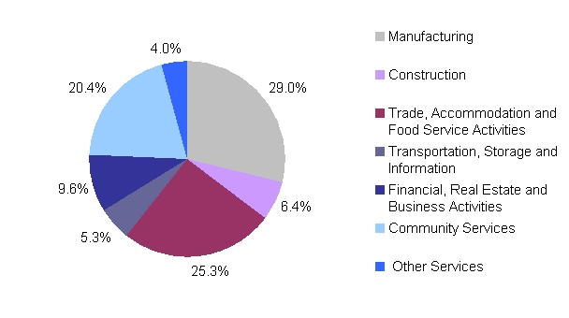
Source: HLS 2009, “Entry of young people into the labor market“, Turkstat; Betam

Parental education levels are provided in Table 2. Note that there is an important gender gap in education levels in Turkey, especially among older cohorts. The data shows that as high as 38.3 percent of mothers are not graduates. Only 61.7 percent hold at least a primary education diploma. On the other hand, a vast majority of fathers are primary school graduates, therefore we chose to concentrate on high school graduation. 82.9 percent of fathers are at most primary school graduates whereas 17.1 percent have high school diplomas or more. According to data, 38.3 percent of mothers are not graduated from any educational institute and 82.9 percent of fathers are not high school graduates; that is to say, they are at most elementary school graduates.

Table 2 Education level of parents
Mother’s education
Non-graduate from any educational institute | 38.3%
At least primary school graduate | 61.7%
Father’s education
Not graduated from high school | 82.9%
At least high school graduate | 17.1%
Source: HLS 2009, “Entry of young people into the labor market“, Turkstat; Betam

The data in Table 3 indicate that father’s education can be an important determinant of own education. Observe that own and parents’ education levels are correlated. Almost half of the individuals who have a father a without high school degree are primary school graduates themselves; only 16.8 percent of them completed higher education. On the other hand, among individuals whose fathers are at least high school graduates, the share of primary school graduates is 7.5 percent, high school graduates is 30 percent and higher education graduates is 62.2 percent. A similar pattern is observed for the education of the mother. Almost half of the individuals whose mothers do not hold any diplomas are at most primary school graduates. For the same group, the probability of holding a tertiary education diploma is 11.6 percent whereas this number is 32.7 percent for those whose mothers are at least primary school graduates.

Table 3 Individual’s education level according to parent’s education levels
 | Father is not high-school graduate | Father is at least high-school graduate | Mother is not graduate of any school | Mother is at least primary school graduate
Non-graduate | 4.0% | 0.2% | 7.4% | 0.8%
Primary | 47.1% | 7.5% | 55.5% | 30.9%
Elementary | 32.1% | 30.0% | 25.5% | 35.6%
Higher-education | 16.8% | 62.2% | 11.6% | 32.7%
Total | 100.0% | 100.0% | 100.0% | 100.0%
Source: HLS 2009, “Entry of young people into the labor market“, Turkstat; Betam

Figure 2 Individual’s wage distribution according to father’s education
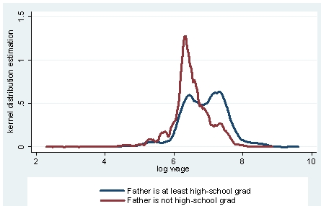
Source: HLS 2009, “Entry of young people into the labor market“, Turkstat; Betam

The distribution of young people’s wages by their father’s education is given in Figure 2. Wages of individuals whose fathers are at least high school graduates seem to be higher than the wages of individuals whose fathers are not. In Figure 3 a similar pattern is observed for the distribution of wages based on the education of the mother.

Figure 3 Individual’s wage distribution according to mother’s education
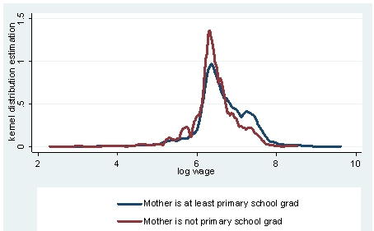
Source: HLS 2009, “Entry of young people into the labor market“, Turkstat; Betam

Having a father who has at least a high school diploma increases wages by 10 percent

Table 4 provides the results of the econometric study. In order to isolate the effects of parents’ education on wages, we controlled for other determinants of wages in the regression.

Our results are in line with the results of previous studies. Women earn lower wages compared to men. Education is one of the most important determinants of wages. Wages are increasing with age and tenure, which reflect the experience in the labor market, but the effects are weaker at higher wages. Note that we also find a marriage premium in wages. This is also consistent with findings for other countries. Not surprisingly, wages of individuals who are not registered at a social security institution are lower. Moreover, there are sectoral differences in wages. Manufacturing sector is selected to be the reference group.

We observe that even when we control for all these factors, we still find that parents’ education has a statistically significant effect on wages. A simple example is the following. Consider two individuals with identical characteristics, including mother’s education, the one whose father is at least a high school graduates earns 10 percent higher wages. Considering that the marginal effect of one year education on wages is 4 percent, 10 percent wage gap is an important difference. Similarly, an individual whose mother is at least primary school graduate earns 2.9 percent higher. Briefly, when we control for education, labor market experience, seniority, operation status of social security registration and sector, parents’ education is still an important determinant of wages.

Intergenerational social mobility

We find parents’ education affects the wages of individuals who are between ages of 15-34, wage or salary earners in the non-agricultural sector. In other words even other factors such as individual's education, experience etc. are controlled for, individuals with more educated parents earn higher wages. Combined, maternal and paternal education together causes nearly a 13 percent increase in wages. These numbers reveal a strong intergenerational transmission mechanism. The effects of transmission mechanisms such as access to education, accumulation of social capital, etc. are important determinants of wages in Turkey. Of course, we cannot separately identify effects of other potentially important determinants such as quality of education, preschool, etc.

In order to increase intergenerational social mobility, which is an important component of social mobility, developed countries recognize the importance of preschool education. It is essential for Turkey to make preschool education mandatory. Furthermore, studies show that the education system in Turkey recreates socioeconomic differences rather than erasing them. The socioeconomic status of parents is an important determinant of students’ academic achievement. Evaluated together, these findings indicate that the education system should be reformed to a system that reduces the socioeconomic disadvantages instead of recreating them. This will have important effects on future generations.

Table 4 Results of Econometric Analysis

 | Log wage
Gender | -0.132***
 | (0.013)
Education of father | 0.100***
 | (0.016)
Education of mother | 0.029*
 | (0.012)
Years of schooling | 0.041***
 | (0.002)
Age | 0.134***
 | (0.013)
Age Square | -0.002***
 | (0.000)
Tenure | 0.042***
 | (0.004)
Tenure Square | -0.002***
 | (0.000)
Marital Status | 0.064***
 | (0.014)
Status of registration | -0.327***
 | (0.015)
Mining and Quarrying | 0.054
 | (0.065)
Electricity, Gas, Steam and Air Conditioning Supply | 0.038
 | (0.069)
Construction | 0.080**
 | (0.025)
Wholesale and Retail Trade | -0.040*
 | (0.017)
Transportation and Storage | 0.060*
 | (0.029)
Accommodation and Food Service Activities | 0.056*
 | (0.024)
Information and Communication | 0.226***
 | (0.050)
Financial and Insurance Activities | 0.281***
 | (0.038)
Real Estate Activities | 0.115
 | (0.149)
Professional, Scientific and Technical Activities | -0.031
 | (0.038)
Administrative and Support Service Activities | -0.093***
 | (0.028)
Public Administration and Defence; Compulsory Social Security | 0.339***
 | (0.026)
Education services | 0.232***
 | (0.024)
Human Health and Social Work Activities | 0.264***
 | (0.028)
Arts, Entertainment and Recreation | 0.044
 | (0.060)
Other Service Activities | -0.197***
 | (0.030)
Constant | 4.033***
 | (0.163)
R-squared | 0.482
N | 6628
* p < 0.05, ** p < 0.01, *** p < 0.001

 Assoc. Prof. Gökçe Uysal, Betam, Vice Director, gokce.uysal @bahcesehir.edu.tr
∗ Merve Yiğit-Yontar, Betam, Research Assistant, merve.yigityontar@bahcesehir.edu.tr
Coté and Healy, The Well-Being of Nations, The Role of Human and Social Capital, OECD, 2001, http://www.oecd.org/dataoecd/36/40/33703702.pdf
“A Family Affair: Intergenerational Social Mobility across OECD Countries”, Economic Policy Reforms, Going for Growth, Part II, Chapter 5, OECD, 2010. http://www.oecd.org/dataoecd/2/7/45002641.pdf
Only 16 percent of fathers did not graduate from an educational institution.

